Chestnut Home Learning
The home learning opportunities we provide allow our children to consolidate and extend their learning. The main purpose of the homework we set is to help children practise basic skills which they need every day in school related to reading, spelling and maths. Additionally, our 9-grid projects provide opportunities for children to follow their own interests as learners and extend their learning about our termly topic/theme.

Reading
Please record your child’s reading practice in their Reading Diary. Each child has a Reading Rewards Chart in school and a stamp is given for each time you record that they read at home. Once they have collected 50 stamps your child will be able to choose a free book. Reading for 5-10 minutes a day really helps your child to develop fluency as a reader and is better for them, than reading for 30 minutes at the weekend. We expect children to read at least 5 times a week at home.

Phonics
Children in YR and Y1 will be given phonemes (phonic sounds) to learn. For useful parent guides to phonics follow this link:
https://www.oxfordowl.co.uk/for-home/reading/phonics-made-easy

Spellings for Y2 – Y6 are set weekly, with a test the following week. The spellings will be based on the statutory spelling lists and the English programmes of study in the National Curriculum. Children will be expected to practise their spellings weekly at home using the techniques learnt in class.
You can find the National Curriculum document here:
https://www.gov.uk/government/publications/national-curriculum-in-england-english-programmes-of-study
Spelling lists for Y3/4 and Y5?6 can also be found here:
https://www.oxfordowl.co.uk/for-home/english--1/spelling-at-primary-school/
Each child in Y1 – Y6 has their own https://spellingframe.co.uk/ password for further spelling practice.

Maths Facts
Maths facts are the facts which your child needs to have at their fingertips so that they can use them to solve calculations. We practise maths facts regularly in school but expect that children practise them at home too. Children should know these maths facts without writing them down, although that may be part of the learning process. All children from YR-Y6 will be given a Key Instant Recall Facts sheet to learn every half term, which also has suggestions about how you can learn these facts.
Some useful websites for practising number facts are:
https://www.topmarks.co.uk/maths-games/hit-the-button
https://www.topmarks.co.uk/Search.aspx?Subject=16
Each child in Y1 – Y6 has their own https://www.mathletics.com/uk/for-schools/ password for further maths facts practice.
Topic Home Learning – Autumn Term 2020
This homework enables you to take an active part in your child’s learning. It will help to deepen their knowledge and understanding of our topic, which this half term is ‘The place where I live’.
The central task is in bold and is compulsory; the other eight tasks are optional. Tasks may be completed in whatever form your child chooses – handwritten, word processed etc. They may want to include photos or other methods of recording. We encourage children to complete and present their work in creative ways. E.g. print, posters, painting, IT presentations, videos, cookery, sculpture, junk modelling, knitting etc. The process of each task is more important than the outcome so if your child is making a puppet it is not about how wonderful the puppet is at the end, but the skills and methods they have used to make it. These tasks include problem solving activities, encouraging your child to overcoming difficulties and learn from their mistakes. This homework is set over half a term and due in no later than the week beginning Monday 2nd November 2020. There is plenty of time to complete these projects, so get creative and show us what you can do!
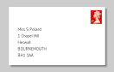  Write a letter to a family member. Talk about how we send letters in the post and practise writing your address. You never know, you might just get a reply! | Can you design and make a number problems board game for children in your class to play? It could include addition, subtraction and multiplication.  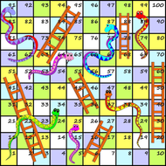 | 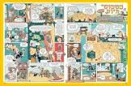  Can you find any interesting things to read other than a book? This could be a comic, a leaflet, something on the computer. Write a short review of your reading.
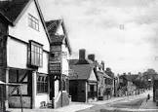  What did your home or local area look like in the past? Research and create a presentation to show what your home looked like in the past. | 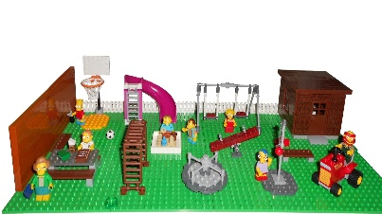  Create a model playground using whatever material you like. You could use Lego, lollypop sticks or straws. Think about what equipment is in your local playground.  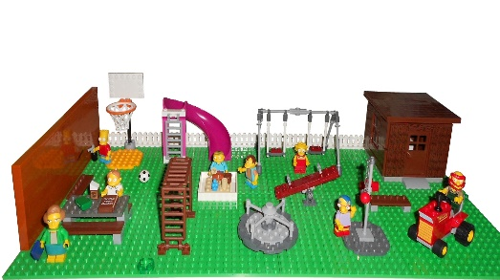 | 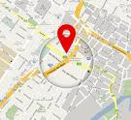  We are developing our map reading skills in our geography lessons. Can you find your house on a map? Look at a map or online to try and find your house. How can you tell it’s your house? Present your findings to the class.
Make something to celebrate at our class harvest worship. This could be a seed collage, a prayer, a painting, a collection of photos…  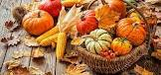 | 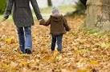  Outside Learning: Go on a sound walk. Write a list or draw the different sounds you hear along your journey i.e. birds singing, leaves crunching. | Research the food chain of your favourite animal, what does it eat? Does it have any predators? Can you think of a creative way to present this information?  