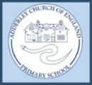
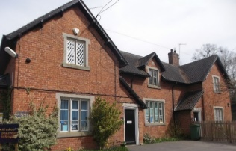
News from Adderley CE Primary School
‘Love your neighbour as yourself’
Christian Values:
Our Christian Value this half term is respect. Respect is a fabulous value to focus on as we welcome children back to school after the summer break. Over the next half term, we will guide our children to discover the importance of respecting ourselves but also our friends, family, community and the environment.

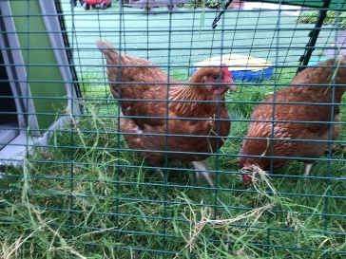
Chickens have arrived at Adderley!
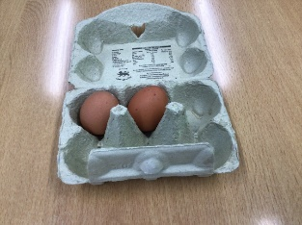
This week we have seen the arrival of two lovely, fluffy ladies- Daisy and Maisy. Staff firstly had the opportunity to take part in ‘Chicken training’ and now have a thorough understanding of the beauty of what these lovely ladies can bring to our school family.
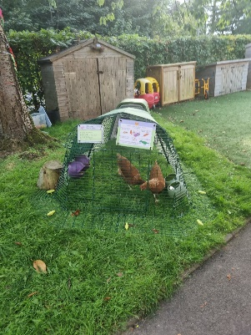
The children and staff took part in a vote to name the chickens and we have organised a rota of children to take the eggs home once they start laying consistently. Our ladies are young and we are pleased to announce we have our first egg!

Over these first day back, the children have thoroughly enjoyed getting to know our new feathered friends and have taken responsibility for feeding and taking care of them.
Daisy and Maisy are currently undergoing their own form of chicken training and will be able to roam freely through the school grounds.
 01630 653 829
 adderleyadmin@addmorefed.shropshire.sch.uk
 https://www.adderley.shropshire.sch.uk/

