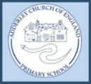
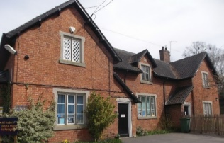
News from Adderley CE Primary School
‘Love your neighbour as yourself’
Christian Values:
Our Christian Value this half term is respect. Respect is a fabulous value to focus on as we settle back into our school routines. Over this half term, we will guide our children to discover the importance of respecting not only ourselves but also our friends, family, community and the environment.
Harvest Festival
On Thursday 12th October the whole school took part in a harvest celebration at St Peters Church in Adderley. After a beautiful walk in the October sunshine, the children were quick to settle and prepare for their performances. The children sang a variety of harvest and autumn themed songs, including some classics such as cauliflowers fluffy. It was wonderful to hear the children read their prayers and poems and myself and Mrs Jones are incredibly proud of how well the children did. It was also lovely to welcome our new vicar – Rev Michael- and the children and parents took full advantage of his invitation to high five the vicar on the way out of church.
This service wouldn’t have been possible with the support and creative flair of our Music Teacher Mrs Vaughan. Mrs Vaughan has practiced tirelessly with all the children and it was so lovely to see new songs being introduced alongside music instruments.
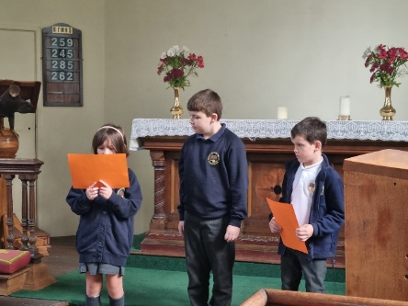
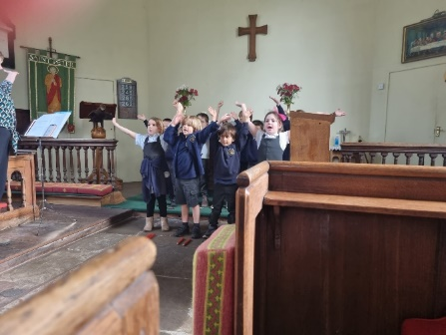
 01630 653 829
 adderleyadmin@addmorefed.shropshire.sch.uk
 https://www.adderley.shropshire.sch.uk/

