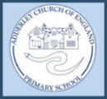
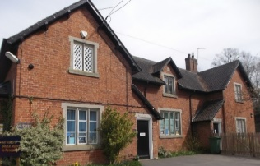
Adderley C of E Primary School
‘Love your neighbour as yourself’
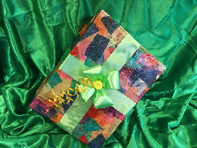
Christian Values:
Our Christian Value this half term is Hopefulness. As we start to look towards the Christmas festivities and a new year, hope is a wonderful value that will help us to be thankful for all that we have, while looking forward to the future.
Children in Need
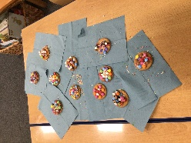
On Friday 17th November, the whole school came together to raise money for Children in Need. The children were invited to come to school dressed in either yellow, spots or their own clothes. To raise money, the children took part in a variety of activities throughout the day such as: biscuit decorating, guess how many spots competition, colouring competitions and fill the Pudsey bear with spare change. Our PTA also held a cake sale at the end of the day to add to our total.
Carols Around the Campfire
The PTA and staff have now started preparations for our annual ‘Carols around the Campfire’. This event is one of our main fundraisers and brings the school community togewther to enjoy festive cheer and a sense of belonging. This is a wonderful opportunity for our families to explore and appreciate the wonderful grounds that we are lucky to have. After the carols have finished, our families will enjoy a variety of stalls including games and crafts. Hot food and drinks will also be very much enjoyed.
Adderley Village Hall Lights Switch On
On Friday the 8th November, we are delighted to once again join hands with the Adderley Village Hall and Church for the Adderley Light Switch on. The school and PTA will be offering a variety of stalls for the local community to enjoy. We hope to see you there!
 01630 653 829
 adderleyadmin@addmorefed.shropshire.sch.uk
 https://www.adderley.shropshire.sch.uk/

