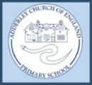
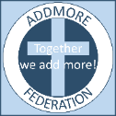
Adderley C of E Primary School
‘Love your neighbour as yourself’
Our Christian Value this half term is Justice ‘Learn to do right. Seek justice.’ Isaiah 1.17
This half term the children will explore how we can all treat people fairly and the importance of following rules.
Interfaith Day
As part of our R.E curriculum we love taking opportunities to learn about different world religions, encouraging understanding, tolerance, empathy and bringing communities together. For our Interfaith Day this term, we decided to focus on the Jewish religion with a particular focus on the festival of Hannukah.
To kick start the day and to give children a true flavour for the Jewish religion we welcomed Sue into our classrooms to speak about Judaism, the faith she practices. It was fascinating to hear all about Jewish festivals and practices.
The children also cooked traditional Latkes (potato and onion cakes), made the star of David from natural materials in the forest, draw their own Menorahs and design, make and play the dreidel game.
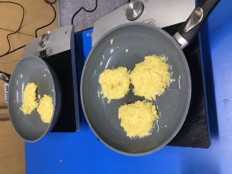
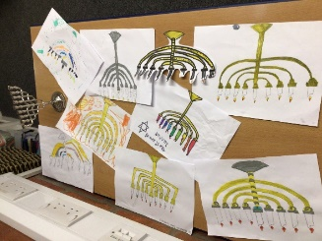
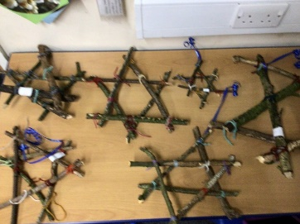

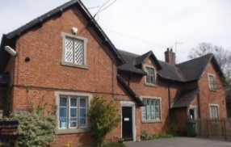
 01630 653 829
 adderleyadmin@addmorefed.shropshire.sch.uk
 https://www.adderley.shropshire.sch.uk/

