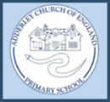
Adderley C of E Primary School
‘Love your neighbour as yourself’
Our Christian Value this half term is: Compassion
‘‘Clothe yourselves with compassion, kindness, humility, gentleness and patience.’
This half term the children will explore how we can show compassion and kindness to each other, ourselves and the community.
Young Voices
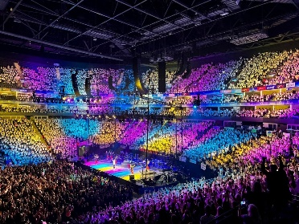
What an amazing day we’ve just had in Birmingham. Seeing the children from both schools joining together, having fun and singing their hearts out was a very special moment. We got the opportunity to be part of a 6,000 strong choir with other schools from all over the region. We rehearsed with a top conductor and were accompanied by fantastic musicians. We rapped, sang gospel, pop and musicals, Korean folk songs and songs from the films Matilda and Moanna. We also got interviewed by a film crew and danced with a street dance group.
Well done to all the children for practising every week, loving their singing and doing us proud.

 01630 653 829
 adderleyadmin@addmorefed.shropshire.sch.uk
 https://www.adderley.shropshire.sch.uk/

